Chapter 10, Problem 23.

Using nodal analysis obtain V in the circuit shown in Fig. 10.72.

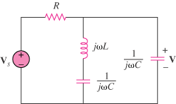

Figure 10.72
For Prob. 10.23.

